**Name: Kanak Agrawal**

**Day-5 Assignment**

**Question: Rank Function**

**Answer:** The functions are provided to rank the records in the table. The following functions are provided for the rank records.

**1) row_number()**

**2) rank ()**

**3) dense_rank ()**

**4) ntile ()**

* **ROW NUMBER()**

**Query:** select ROW_NUMBER() OVER (

ORDER BY id

) row_num,

name

FROM employee;

**Output:**

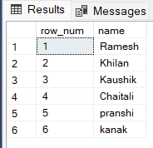

* **RANK()**

**Query:** select name,

Rank () over (

order by name

) As rank_no

from employee;

**Output:**

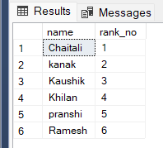

* **DENSE RANK()**

**Query:** select

DENSE_RANK() over (partition by salary order by age desc) as rank,

salary,age,name

from employee order by salary,age desc;

**Output:**

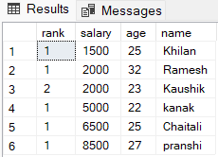

* **NTILE**

**Query:** SELECT id,

NTILE (3) OVER (

ORDER BY id

) Group_number

FROM employee;

**Output:**

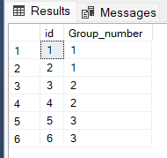

**Question: Sql Procedures**

**Query:** CREATE PROCEDURE us_employee AS

SELECT id, name

FROM employee

WHERE state = 'Delhi';

**Output:**

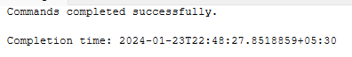

**Question: Data Cleansing**

**Answer:** Step by step procedure to apply data cleansing

1. Check for Missing Values

2. Check for Duplicates

1. Check for Missing values

* **IS NULL**

**Query:** SELECT NAME, PRIZE, BREEDTYPE

FROM USERS

WHERE BREEDTYPE IS NULL;

**Output:**

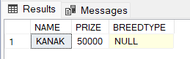

* **COALESCE**

**Query:** SELECT COALESCE(NULL, 1, 2, 'Kanak.com');

**Output:**

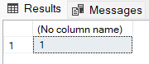

1. Check for Duplicates

* **GROUP BY & HAVING**

**Query:** SELECT COUNT(CustomerID), country

FROM employee

GROUP BY country

HAVING COUNT(CustomerID) > 3;

**Output:**

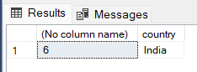

* **DISTINCT**

**Query:** select distinct name from employee;

**Output:**

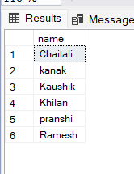

* **DELETE**

**Query:** delete from employee

where id =6;

**Output:**

